- Train a simple scikit-learn DecisionTreeClassifier on a small dataset of your choice (for example, a list of songs with genres from your Spotify playlist), then use Pickle to save the trained model to a file named song_genre_model.pkl.

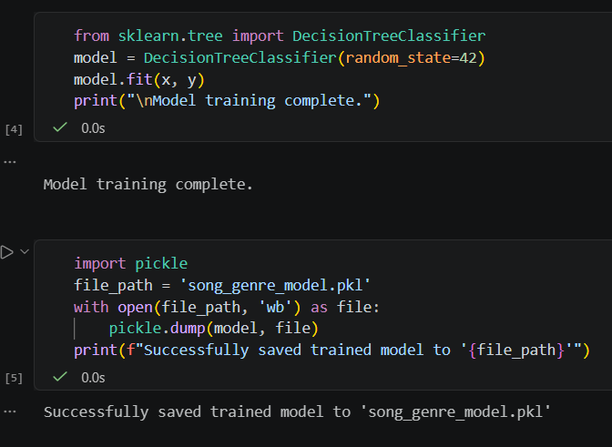

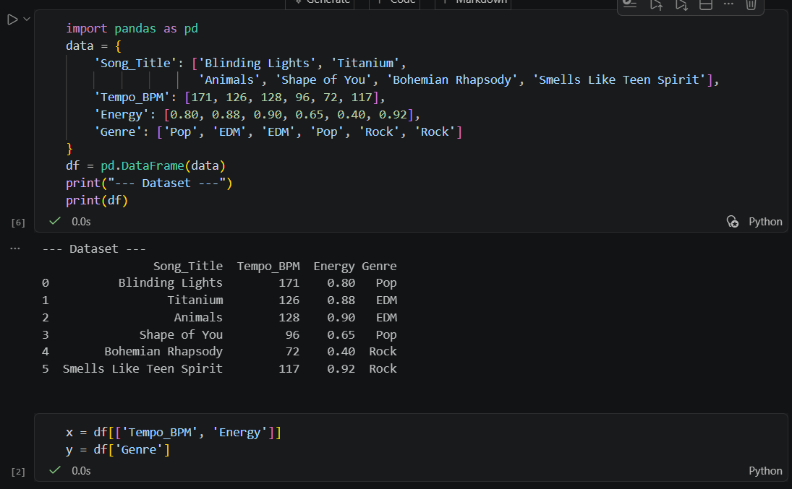

- Load the song_genre_model.pkl file you saved earlier and use it to predict the genre for a new song entry, printing the predicted result.

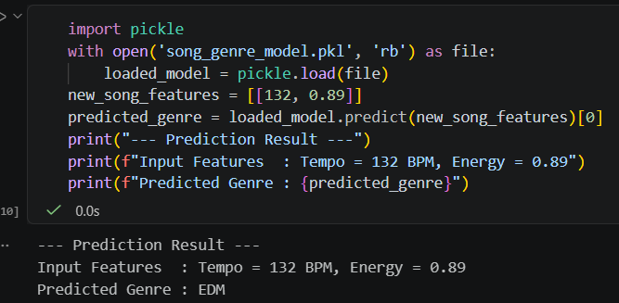

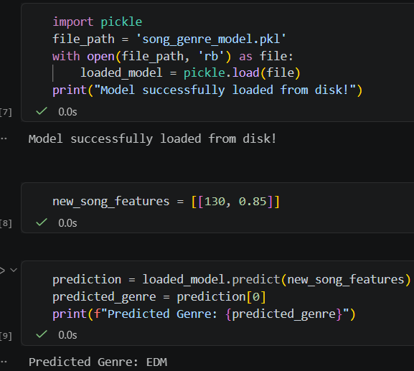
- Train a scikit-learn KNeighborsClassifier to predict whether a Flipkart product is 'electronics' or 'fashion' based on sample features, then use Joblib to save the model as product_category_model.joblib. Use joblib.dump() for saving and joblib.load() for loading.
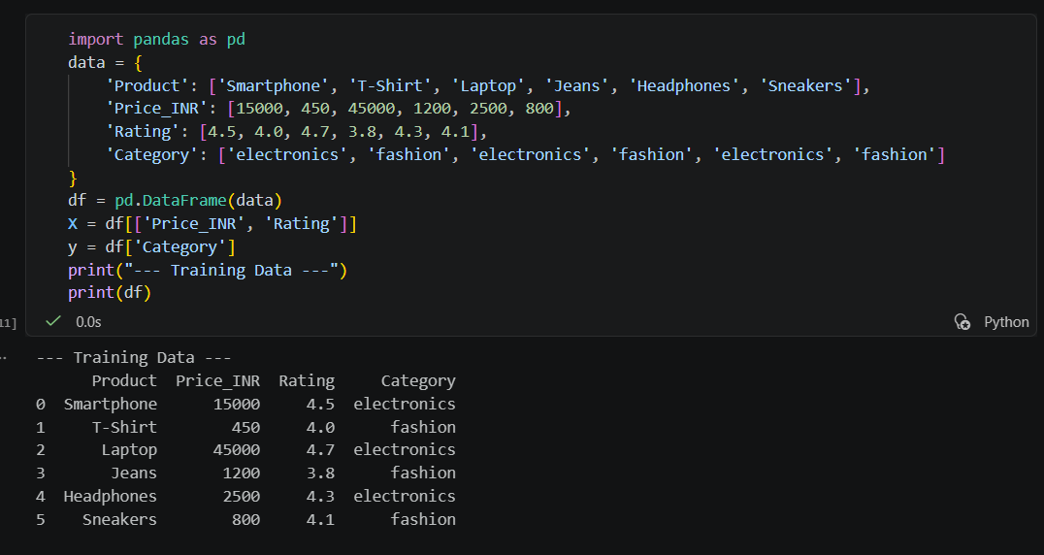

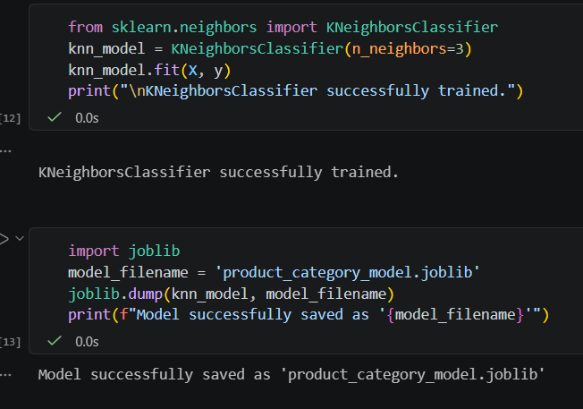

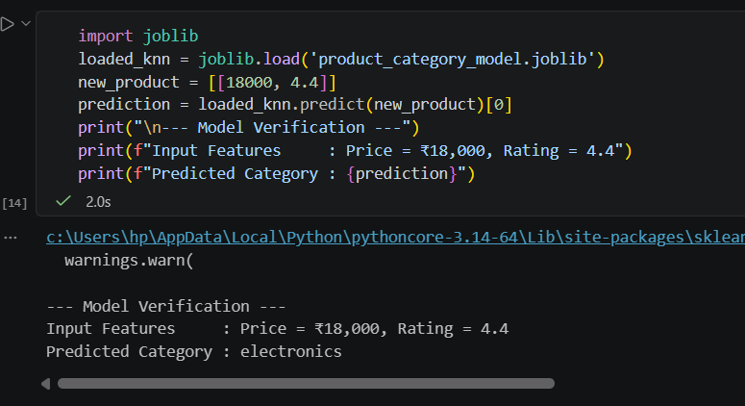

=====================================================================

- Suppose you have trained and saved two versions of a model (v1 and v2) for predicting Zomato restaurant ratings. Create a folder structure for model versioning (e.g., models/v1/, models/v2/) and explain in a comment how you would keep track of which version is currently deployed.

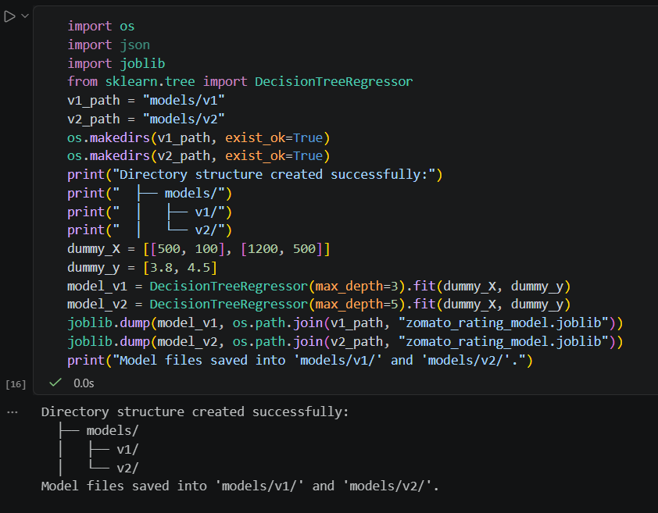

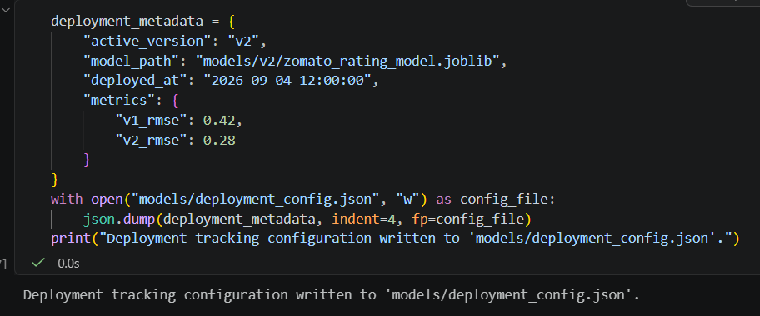

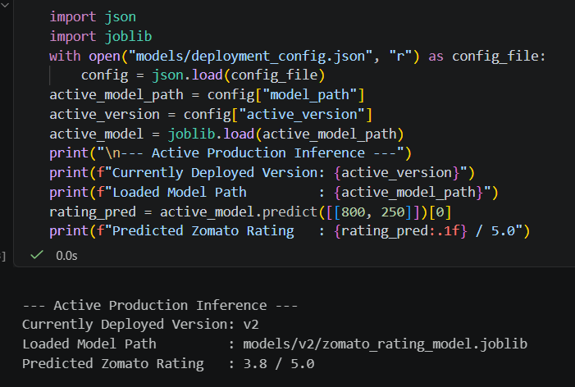

- List three best practices for storing and managing machine learning model files in a real-world app like BookMyShow, and briefly explain why each is important.

1. Store Models in Cloud Object Storage (Not Git Repositories)
- What to do: Save serialized model artifacts (.pkl, .joblib, .onnx) in cloud object storage solutions like AWS S3, Google Cloud Storage, or Azure Blob Storage.
- Why it matters:
  - Git Bloat: Machine learning binary models can easily range from hundreds of megabytes to several gigabytes. Tracking these binaries inside Git repositories quickly bloats repository size, slows down git clone / git pull operations, and creates severe merge conflicts.
  - Scalability & Security: Cloud object stores offer cheap storage, granular access controls (IAM roles), and direct, fast streaming downloads for API web instances.
2. Use a Model Registry with Full Lineage and Metadata Tracking
- What to do: Implement dedicated Model Registry systems (such as MLflow Registry, DVC, or AWS SageMaker Model Registry) to track each model artifact alongside its metadata.
- Why it matters:
  - Reproducibility & Lineage: Storing just the binary file isn't enough. You must track the exact dataset snapshot, hyperparameters, code commit SHA, and evaluation metrics (e.g., Accuracy, RMSE, Latency) used to generate that artifact.
  - Lifecycle Management: A registry allows engineering teams to tag versions clearly (e.g., v1.2.0-Staging, v2.0.1-Production, v1.0.0-Archived). If a new movie recommendation model generates incorrect output under high live traffic, the system can instantly roll back to the last known stable model tag.
3. Enforce Cryptographic Checks and Secure Serialization Protocols
- What to do: Avoid raw pickle files in untrusted environments. Use secure serialization formats like ONNX or Safetensors, and verify file integrity using SHA-256 checksums before loading model weights into memory.
- Why it matters:
  - Security (Arbitrary Code Execution): Python's standard pickle library deserializes data by executing underlying Python bytecode. Loading an unverified or tampered .pkl file over an open network can allow an attacker to run malicious code on production application servers.
  - Framework Independence: Formats like ONNX (Open Neural Network Exchange) allow models trained in PyTorch or Scikit-learn to run efficiently on specialized, optimized C++ runtime inference engines without requiring heavy Python runtime overhead.

